Specialist Test 1 Notes – Year 11 2023

By Ajay Bisnath

**Remember QED!!**

**Sets of Numbers:**

* + - natural numbers
  + $Z$- all integers
  + $Q$- all rational numbers
    - numbers that can be written as $\frac{a}{b}$ where $a$ and $b$ are both integers ( $b$ $≠$ 0)
  + $R$- all real numbers

**Representing Numbers:**

* If n is even: n = 2k **for some** k $∈$ $Z$
* If n is odd: n = 2k + 1 for some k $∈$ $Z$
* If n is a multiple of x/is divisible by x: n = xk for some k $∈$ $Z$
* If n is rational: n = $\frac{a}{b}$ for some (a, b) $∈$ $Z$

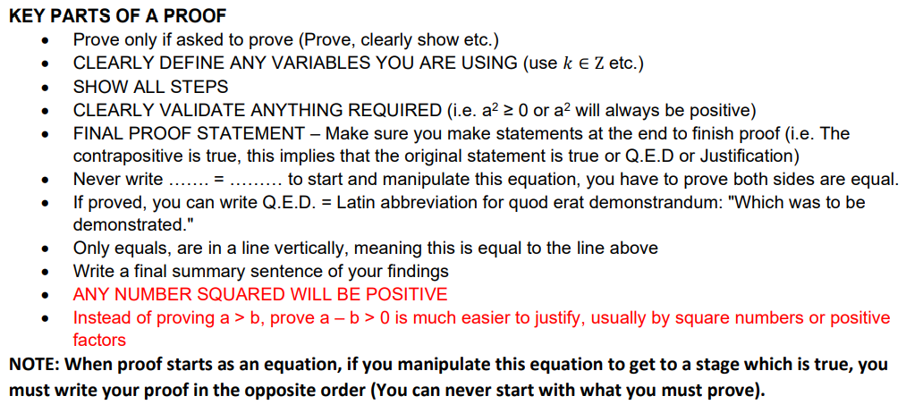

**Proof by Contrapositive (If not *B* then not *A*):**

* Graphical user interface, text, application

  Description automatically generatedThe contrapositive of a true conditional statement is also true and vice-versa.

**Disproving Statements:**

Universal quantification: ‘For all’ (∀) – Every case must be true

Existential quantification: ‘There exists’ (∃) – Only need one example to prove/disprove

**Proving Equivelant Statements:**

* 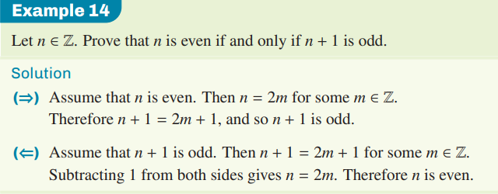E.g.: **A if and only if B** represents both the original and converse statement as true

**Negation:**

* The statement which asserts the opposite
  + E.g., the negation of the statement:
    - '*n* is greater than 12'
    - --> '*n* is less than or equal to 12’
  + and becomes or, or becomes and

**Interval Notation:**

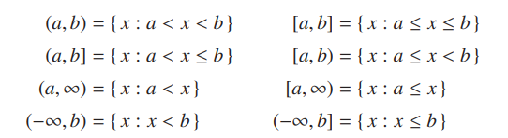

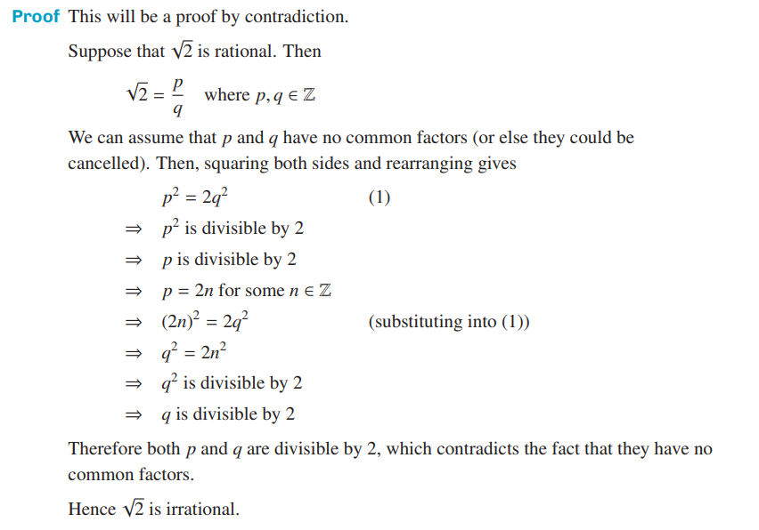**Proof by Contradiction:**

